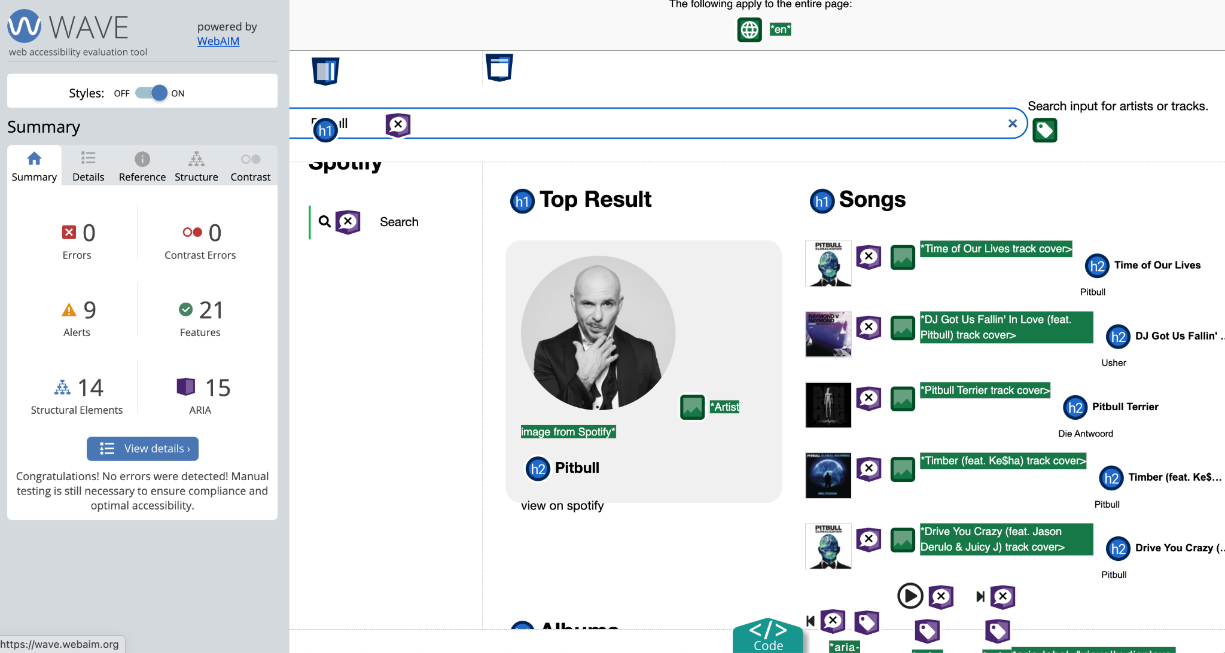

**What corrections did you have to make, and how did you make them?**

I had more than two dozen errors and I was concerned! Every image was missing an alt tag. I was able to put in alt tags in the javascript files that generate the images for the artist image, song images, and album cover images. I used the data syntax (${}) to make sure the name of the song and album were in the alt tag.

I had to add the language to the HTML document, and I also had to add a [label tag](https://www.w3schools.com/tags/tag_label.asp) for the input search bar.

**Is this interface functional without the use of a mouse (i.e., just using keyboard keys)? Why or why not?**

Yes! I was able to use the tab key first to get to the search bar, and then use the enter key to play a track or click on the “view on Spotify” link.

For the search bar, this is because in the javascript file, there is a line that includes keycode 13, which is the enter key. That allows us to click enter to search.

**What are other accessibility tests or features you added or would be interested in learning about?**

One thing I would be interested in learning about is how to use the spacebar to pause and play the music at any point on the webpage. It only worked after I clicked on it once (or used the tab key to hover over it). I think this might be implemented using a global key, but I’m not completely sure.